**Cloud Computing (Elastic Compute Cloud)**

EC2 instance: EC2 instance is a type of AWS module which help to create virtual server machine. While launching EC2 instance we can select hardware related details, OS information, number of machine you want to create. Every EC2 instance provide us public as well as private IP Address.



Angular application backend

Frontend application spring boot eureka server account micro service mysql database.

Public as well as private IP Address.

192.168.10.134 public ip address

197.16.45.678 private ip address

Private IP Address is use to communicate more than one machine or node under one cluster.

Public ip address use to communicate outside network area or cluster or publicly.

Login for AWS

In search option,

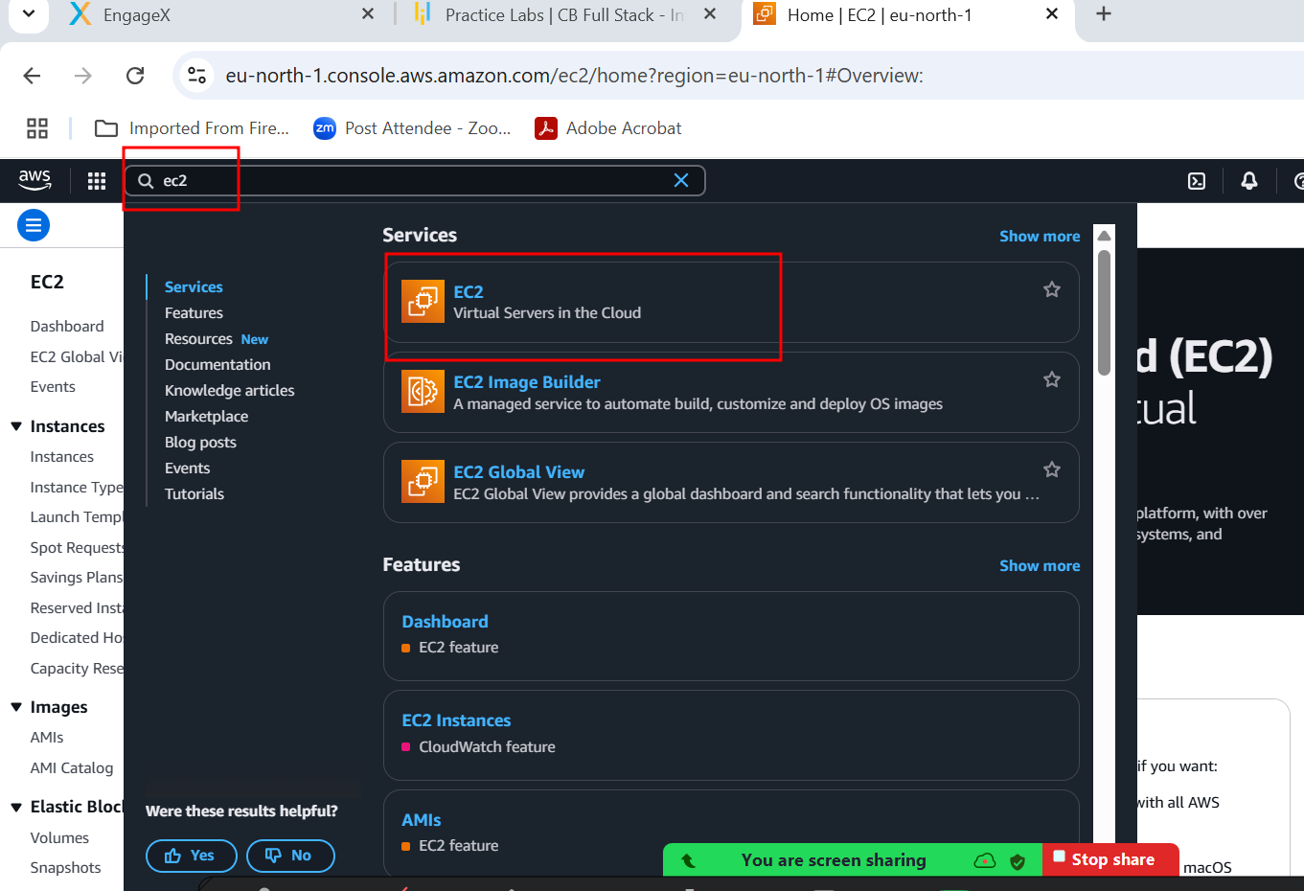

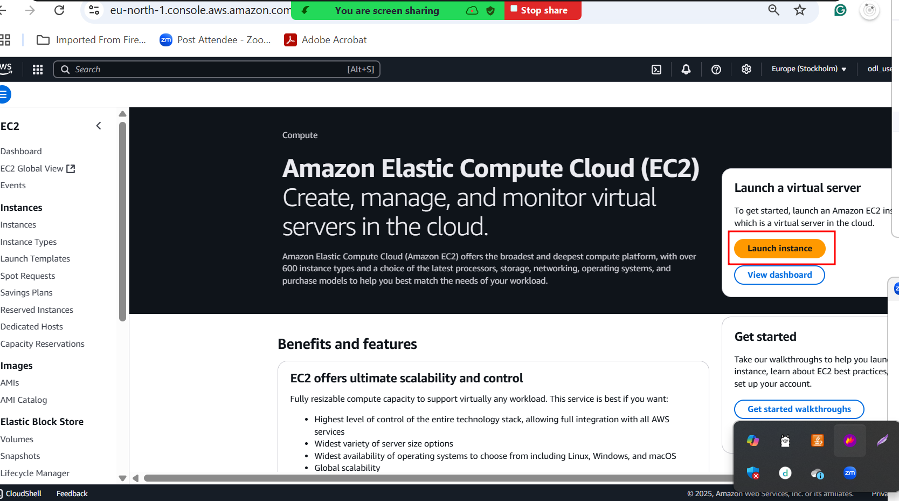

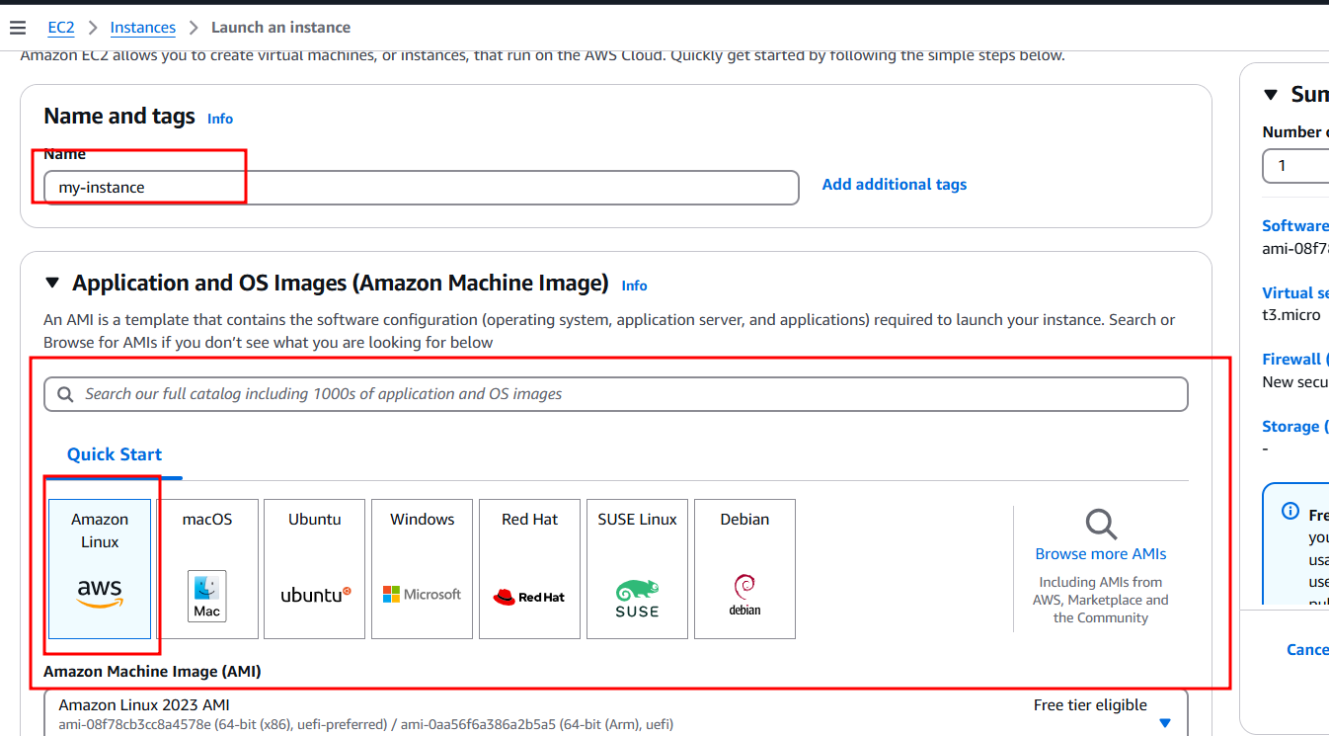

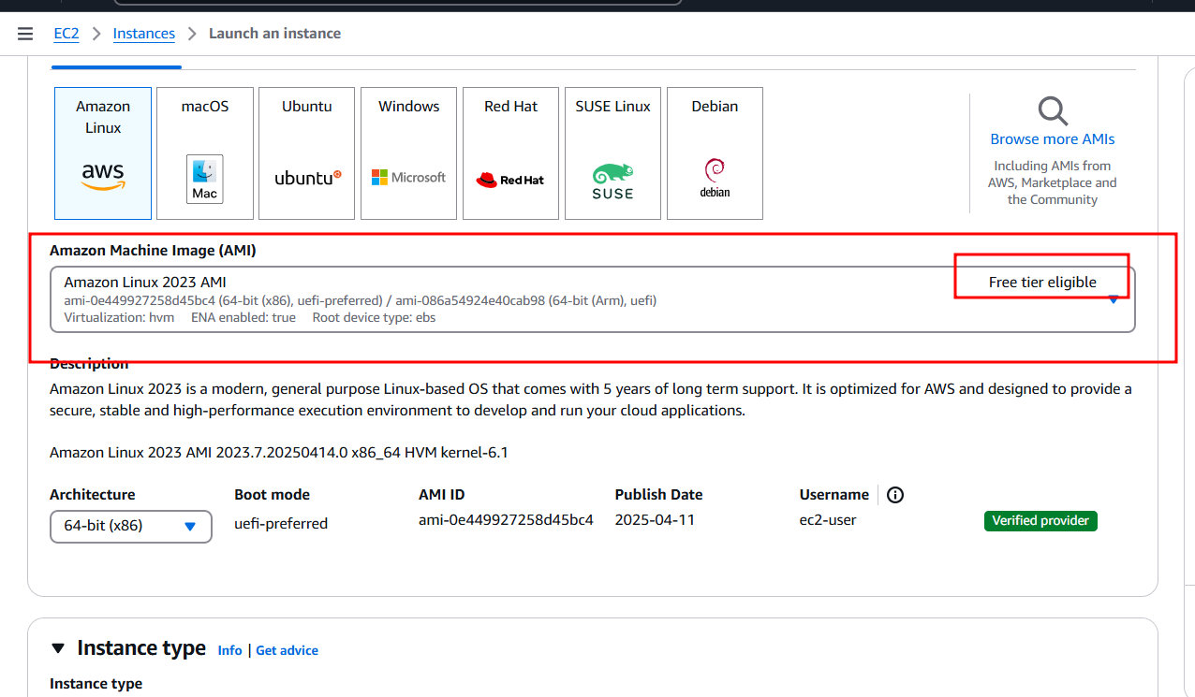

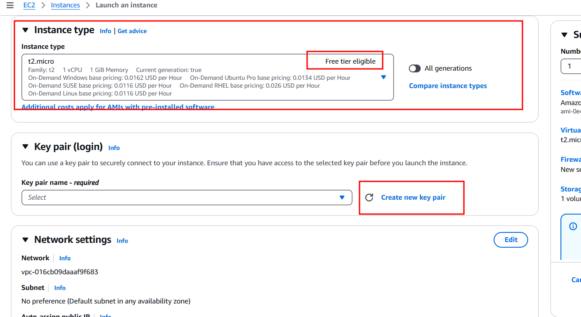

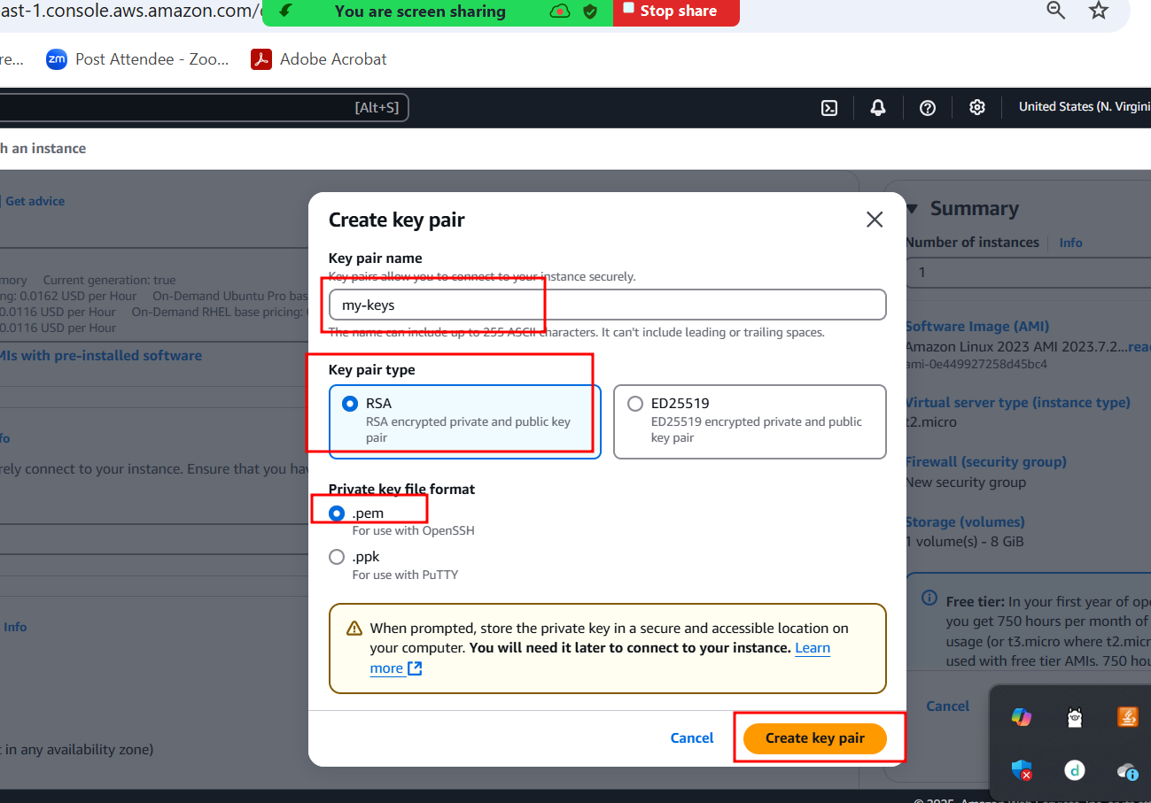

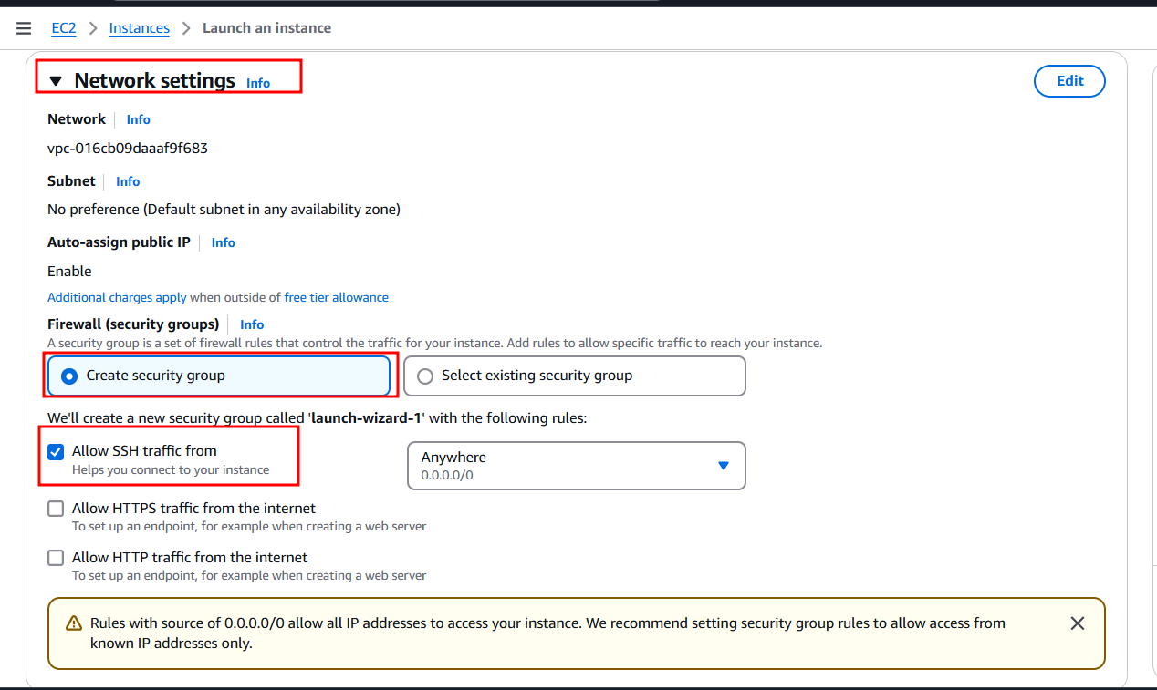

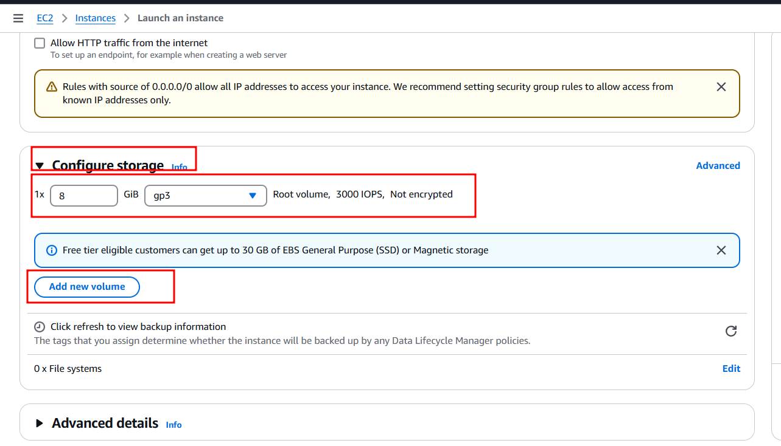

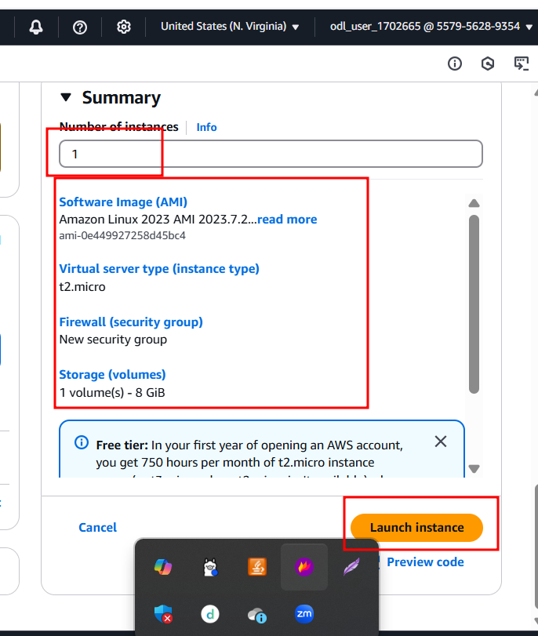

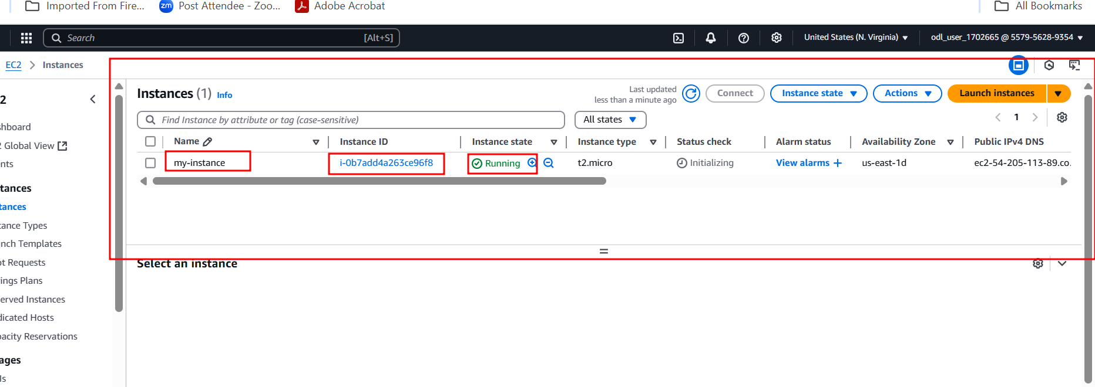

Once the machine or eC2 instance running. To connect that instance please select check box and click connect button.

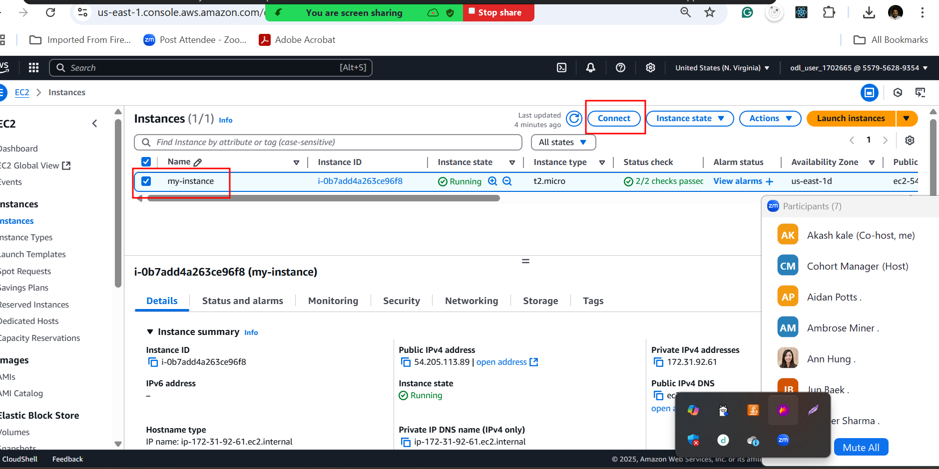

Connecting machine using browser

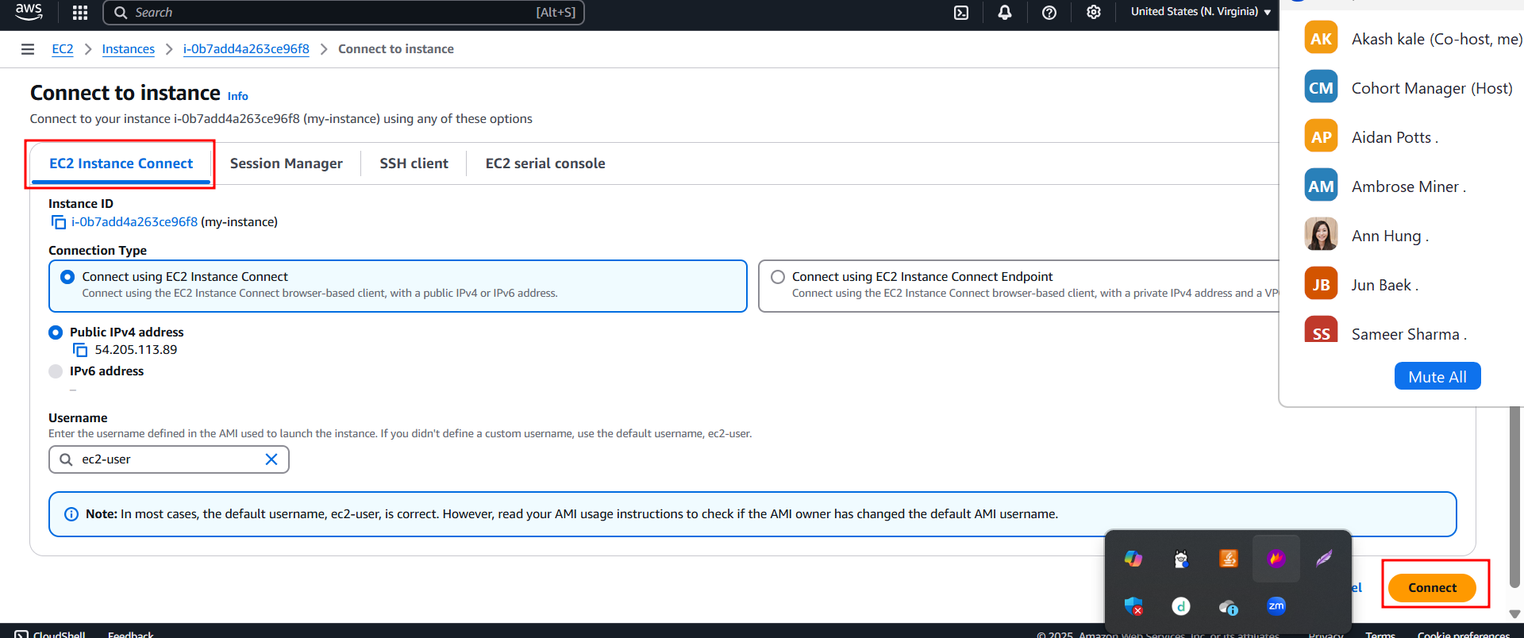

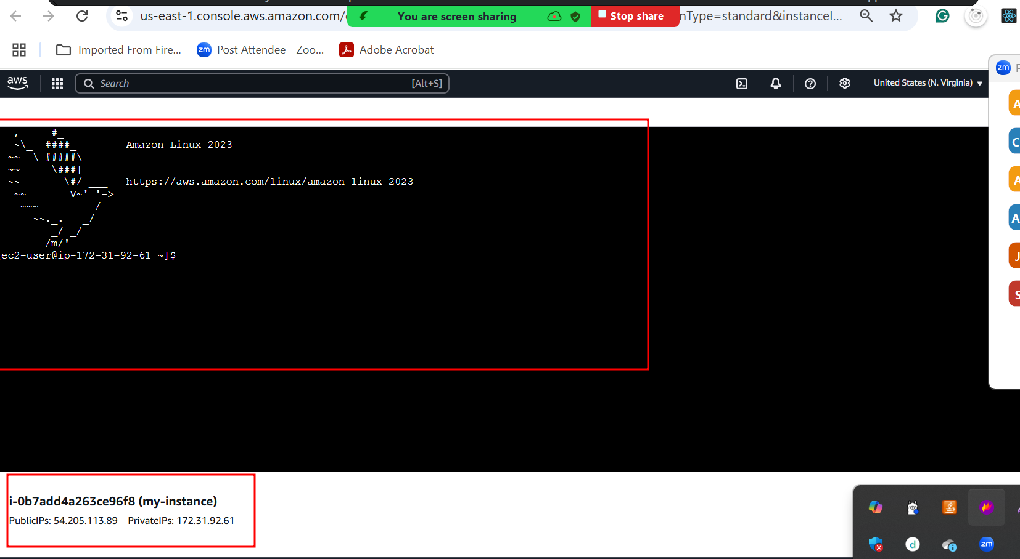

1st create the spring boot project and create the jar file

Upload this jar file in S3 bucket.

If we want to download any files from S3 bucket in EC2 or any aws resource.

We need to use S3 URI.

Below command we need to run on Ec2 instance terminal. To download jar file from s3 bucket to EC2 instance terminal or machine.

wget <https://akash123321484848.s3.us-east-1.amazonaws.com/spring-boot.jar>

once you downloaded jar file on EC2 instance machine. We need to run this java file using below command

java -jar filename.jar

before running jar file. Please install java software using below command as sudo yum install java-17

now you can check the java version

java -version

after install run the jar file

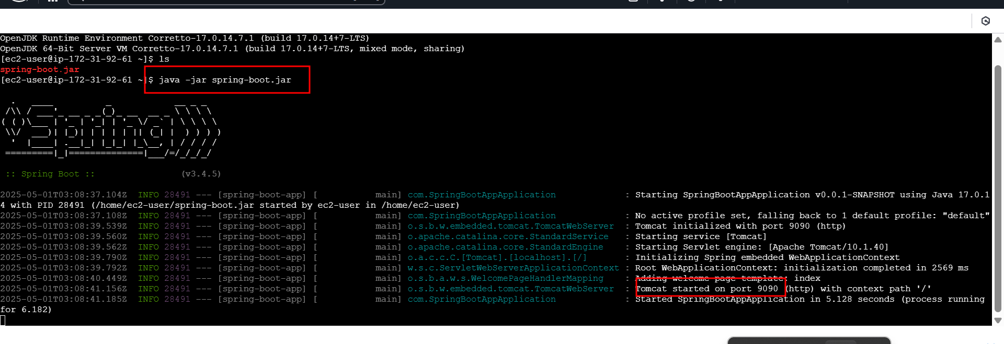

Instance not allow to access any port number. By default only one port number open ie 22 which generally use to connect EC2 instance through browser or SSH client. Depending upon type of application we are/were running on EC2 instance. We need to open those port number in networking setting options.

Our spring boot application running on port number 9090

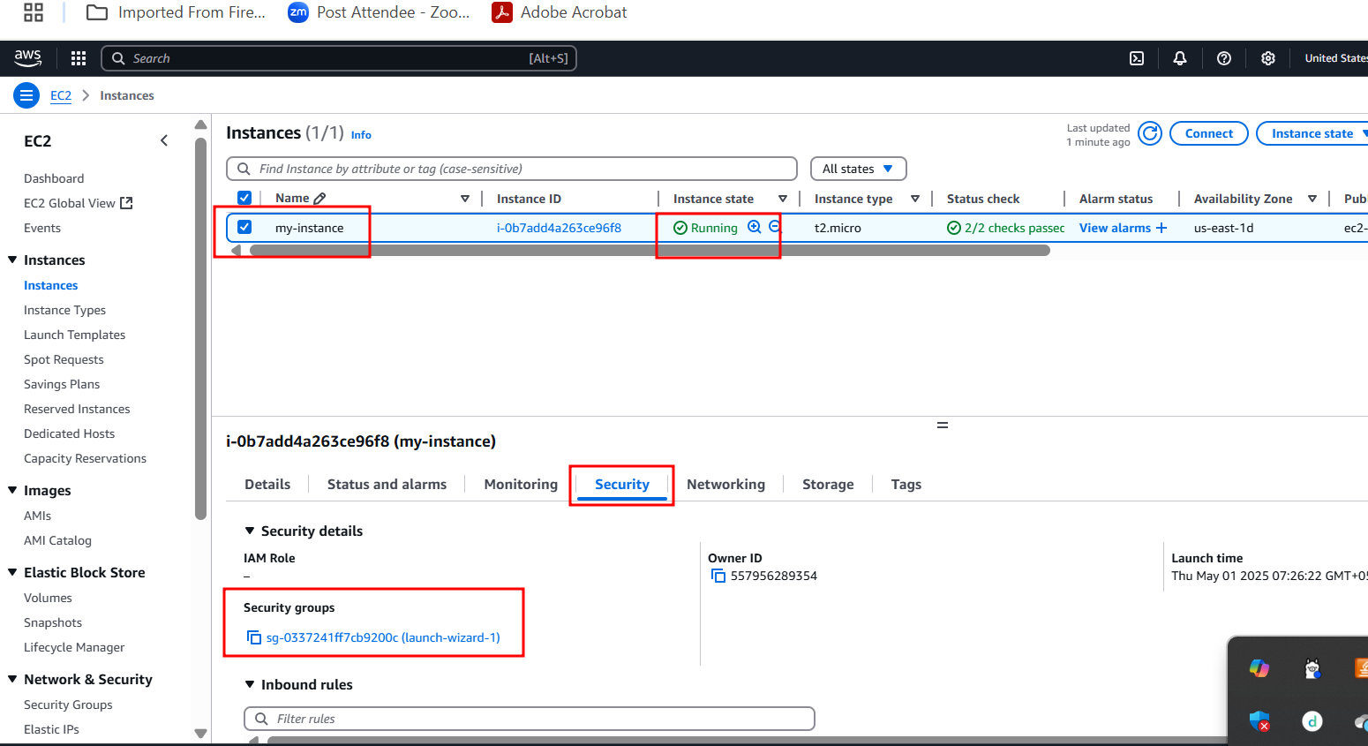

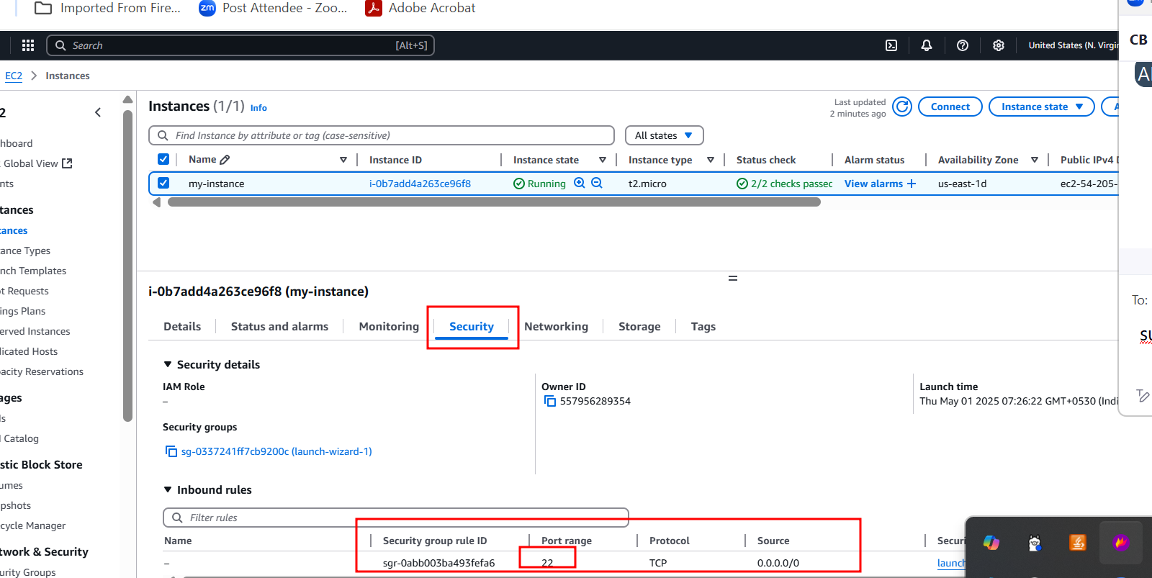

Click on launch wizard

It will open in another tab. If you need change the security group name

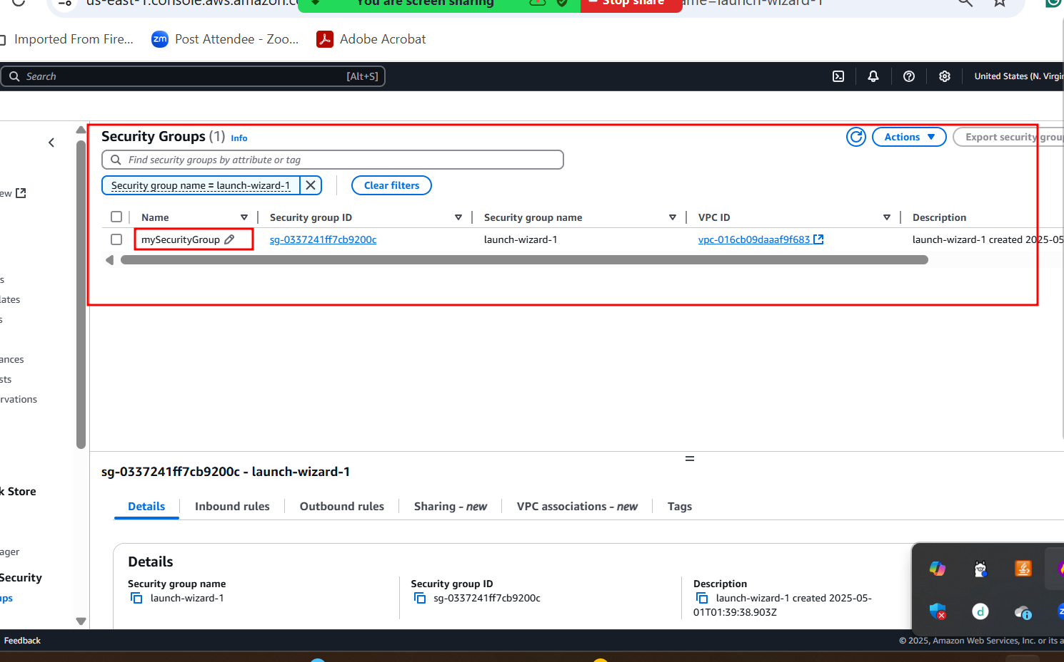

If you need to assign or open different port number. You need to click on edit inbound rule options.

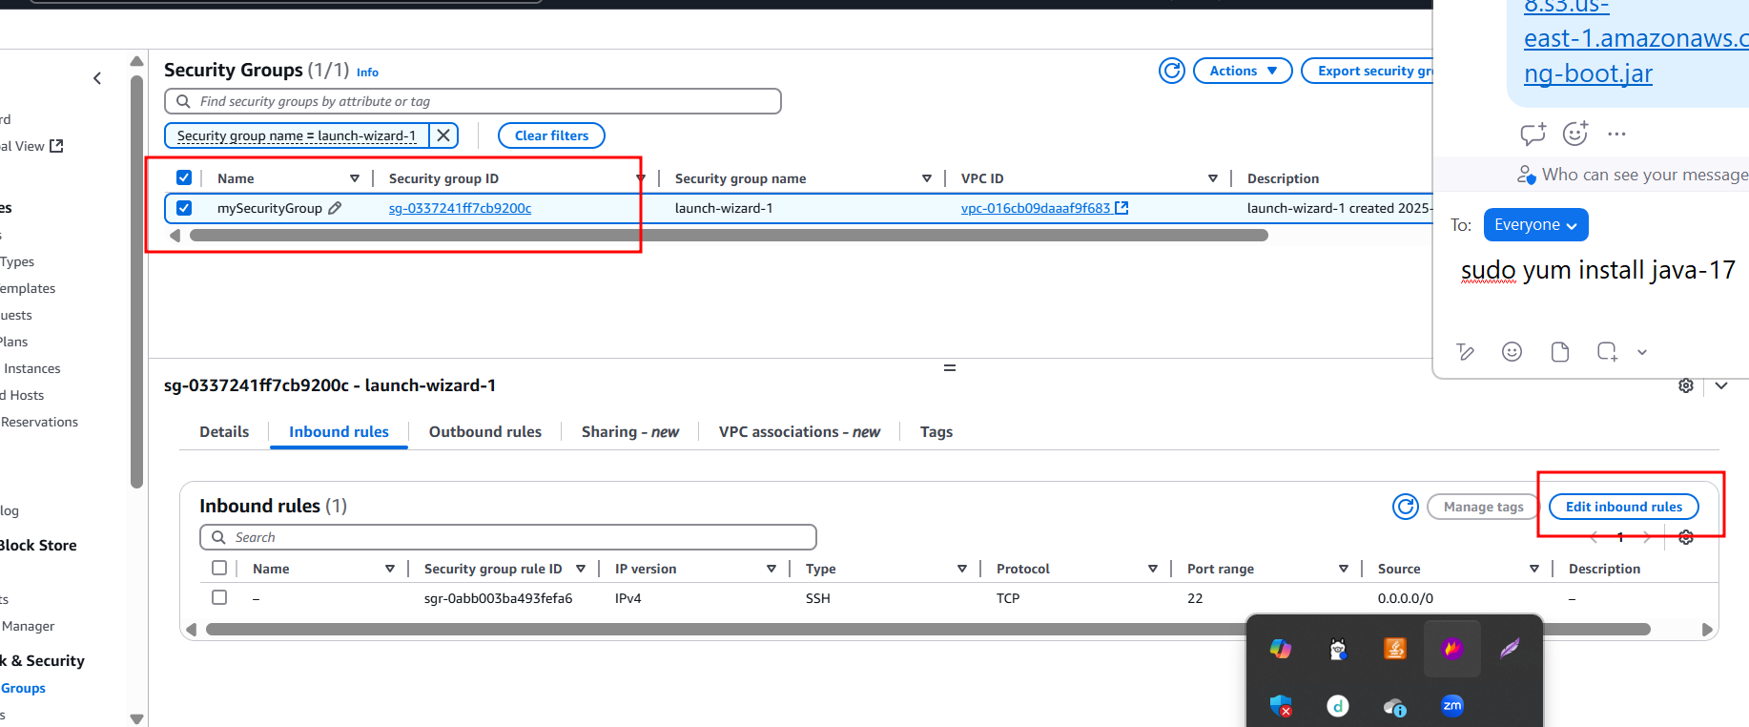

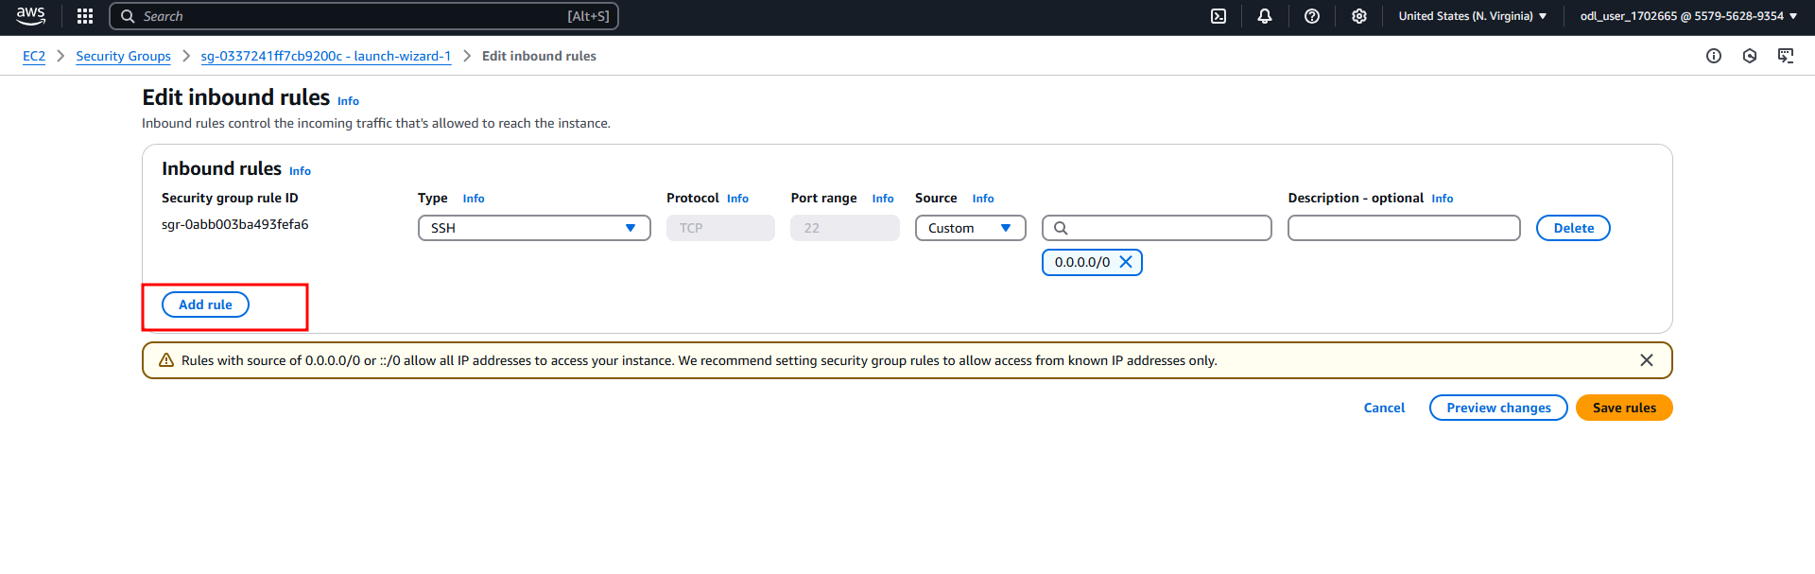

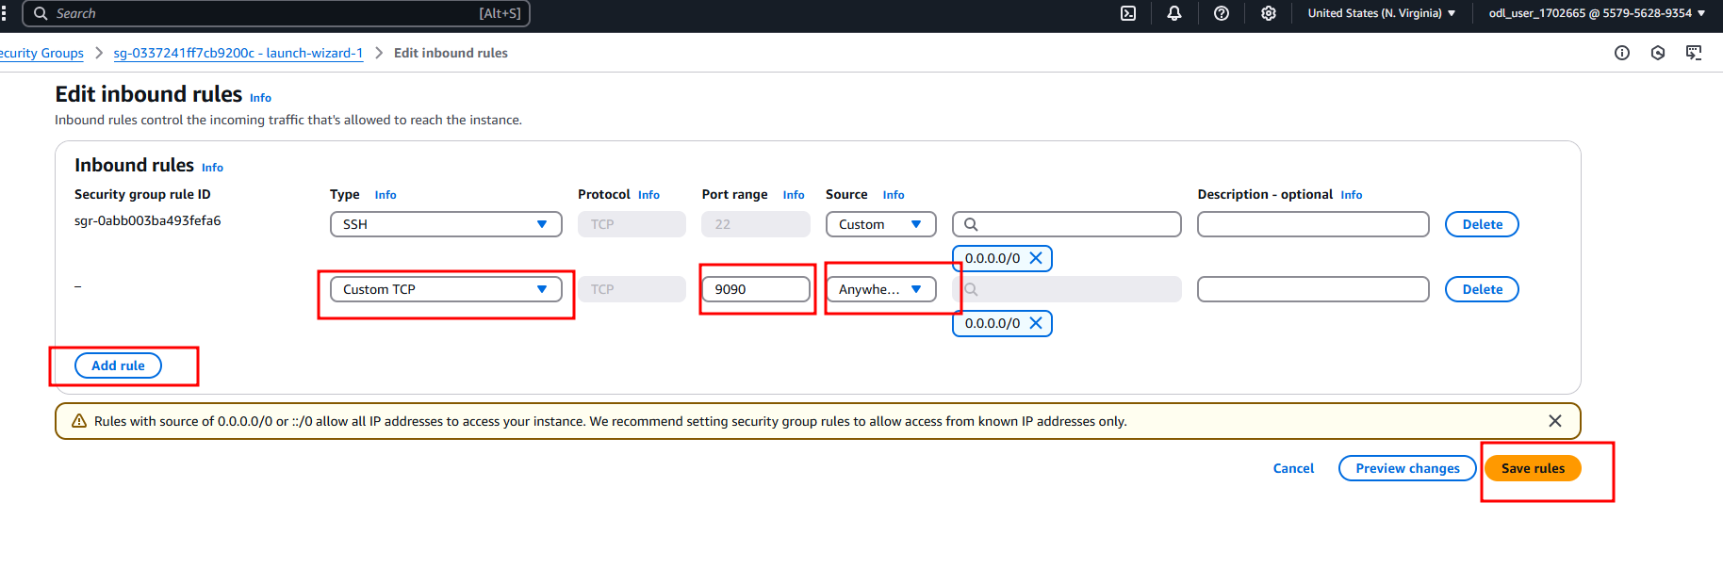

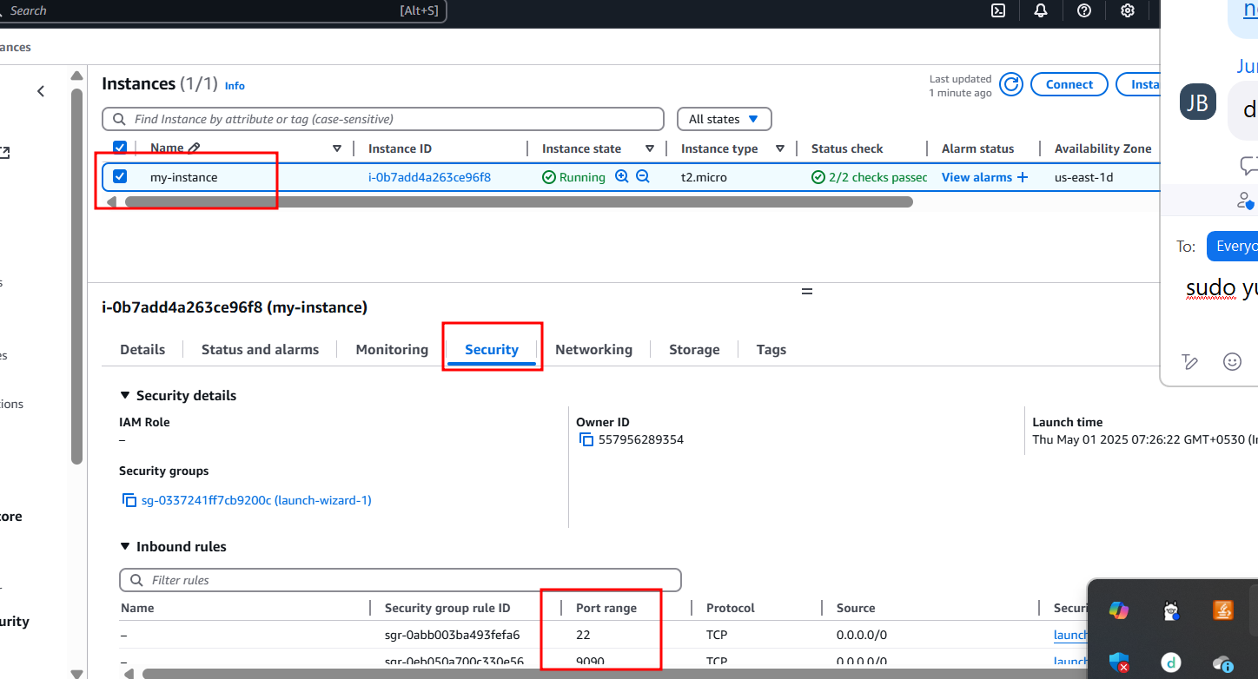

After assign port number run the application using below url as

<http://publicIPAddress:portNumber>

<http://54.205.113.89:9090/>